Introduction

The Department of the Premier and Cabinet acknowledges that Queensland communities have culturally diverse backgrounds with varying needs. DPC is dedicated to actively growing and supporting a culturally diverse community that is both united and harmonious, as well as building organisational cultural competency. This is evidenced through our various achievements during 2018–19, outlined in this report.

Background

- ‘Our story, our future’ is the Queensland Government’s multicultural policy promoting an inclusive, harmonious and united community for Queensland. The policy focuses Queensland Government action on three policy priorities for culturally diverse communities and Queensland as a whole – achieving culturally responsive government; supporting inclusive, harmonious and united communities; and improving economic opportunities.
- The policy is being implemented through a three-year Queensland Multicultural Action Plan 2016–17 – 2018–19.
- The policy and action plan are a requirement of the Multicultural Recognition Act 2016 (the Act) and represent one of three key provisions of the Act – together with establishing the Multicultural Queensland Charter and Multicultural Queensland Advisory Council.
- Section 24 of the Act requires entities with actions in the action plan to report publicly on an annual basis.
- This report fulfils this requirement for the Department of the Premier and Cabinet (DPC) and the Public Service Commission (PSC).

Case study – Harmony Day Reception
Harmony Day Reception. Image courtesy of
Yme Tulleners, Kirkland Photography.
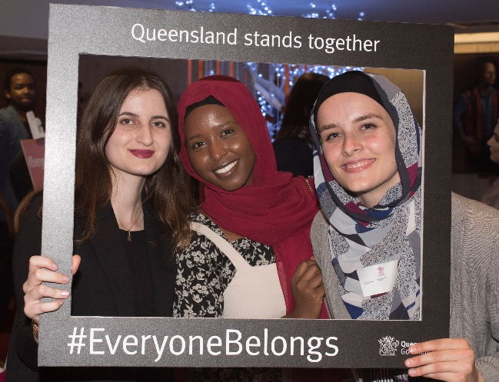
On 26 March 2019, more than 300 Queenslanders from multi-faith communities gathered to show that #EveryoneBelongs at the Premier’s Harmony Day Reception.

The Premier was moved to host the event following the tragic events in Christchurch on 15 March 2019, in which 50 people were killed and many others injured. The Premier, along with many others across Queensland, recognised that Harmony Day – which celebrates our diversity – presented a fitting opportunity to honour the victims and show that ‘Queensland Stands Together’ with all communities.

The highlight for attendees was the Haka and hymn performed by Queenslanders with New Zealand heritage and connections. These touching performances demonstrated our respect for and strong bond with our neighbours and friends across the Tasman Sea. The department’s Protocol and International Engagement team worked with Multicultural Affairs Queensland to deliver this reception. DPC also coordinated a ‘condolence book’ for Queensland public servants and the community to share their messages of support. Guests were also given the opportunity to contribute during the reception. The Premier presented the condolence book – complete with many moving reflections to honour and uplift our treasured international ally – to Hon. Dame Annette King, New Zealand High Commissioner to Australia.
Priority area 1: Culturally responsive government
Outcome: A productive, culturally capable and diverse workforce

Action | Lead | Timeframe | Progress status | Achievements and outcomes
Deliver on the Public Service Commission 2022 foundation non-English speaking background diversity targets for the Queensland Public Sector. | All departments | 2016–19 | On Track | The Leadership Board has committed that by 2022, 10% of Leadership Board agencies’ workers will be from non-English speaking backgrounds.  Minimum Obligatory Human Resource (MOHRI) data at 30 June 2019 reports the:  - overall (aggregated) result for Leadership Board agencies was 10%  - result for the Public Service Commission was 6.76%  - result for the Department of the Premier and Cabinet is 12.74%.  DPC will maintain its minimum and stretch targets (14% and 15% respectively) of staff with a non-English speaking background.  During the period 2016–17 to 2018–19, DPC has continuously exceeded the Public Service Commission (PSC) foundation target of 10% of staff from a non-English speaking background (NESB).  During 2018–2019 DPC implemented an employee engagement program of work to support an inclusive, respectful and socially responsible workforce. The department:  - posted “All Voices” employee profiles on the department’s intranet site which provided employees from a range of different cultural backgrounds with the opportunity to share their stories and the unique perspectives they bring to DPC  - delivered a range of internal activities, aligned to community events, commemorations and celebrations for Harmony Day and Multicultural month  - promoted a range of initiatives related to multiculturalism including Chinese New Year, international mother language day, and the luminous lantern parade.

Priority area 2: Inclusive, harmonious and united communities
Outcome: Connected and resilient communities

Action | Lead | Timeframe | Progress status | Achievements and outcomes
Host receptions for multi-faith leaders and various culturally diverse communities to bridge community connections and promote harmony. | DPC | Various | Completed | The Premier and Minister for Trade hosts various community and business-based receptions throughout the year to acknowledge and celebrate the work that the multicultural community undertakes in Queensland.  Since 2016, there have been 16 official functions coordinated by the Protocol and International Engagement Unit of DPC. In 2018–19 the Premier hosted:  - Multicultural Community Reception – August 2018 with 178 guests in attendance  - Queensland-Japan Networking Reception – September 2018 with 119 guests in attendance  - Indian Community Reception – November 2019 with 385 guests in attendance  - Chinese New Year Reception – February 2019 with 458 guests in attendance  - Harmony Day Reception – March 2019 with 324 guests in attendance.
 |  |  |  | DPC sponsored the India Australia Business and Community Awards 2018 which honours business leaders and members of the Indian community within Australia. The awards recognise the contribution made by Queenslanders and Australians of Indian origin.

Priority area 3: Economic opportunities
Outcome: Queensland gets the most benefit from our diversity and global connections

Action | Lead | Timeframe | Status | Achievements and outcomes
Strengthen global connections through diplomatic visits which strengthen economic relations and promote Queensland as a welcoming and harmonious state. | DPC | 2016–19 | Completed | The Protocol and International Engagement unit of DPC coordinates Diplomatic Visits and Courtesy Calls to Queensland from a wide range of countries including Queensland’s priority trade and investment markets.  In addition, the Premier leads overseas trade missions which also strengthen economic relations by promoting Queensland’s global footprint, outward focused business and community environment and welcomes increased business and community engagement.  During 2018-19 the Protocol and International Engagement unit of DPC hosted 37 Official Visits, Diplomatic Visits and Courtesy Calls to Queensland including:  - Ambassador of South Korea – 7–8 August 2018  - Governor of Nevada – 30 August – 1 September 2018  - Ambassador of Colombia – 5–6 September 2018  - High Commissioner for Bangladesh – 18–19 September 2018  - Chief Executive, Hong Kong The Hon Carrie Lam GBM GBS – 19 November 2018  - Ambassador of Israel – 20–21 November 2018  - Ambassador of Qatar – 12–13 February 2019  - Ambassador of Hungary – 19–20 March 2019  - High Commissioner for New Zealand – 2–3 April 2019  - High Commissioner for Fiji – 16–17 April 2019  - High Commissioner for the United Kingdom – 30 April – 1 May 2019  - Ambassador of Japan – 8–11 May 2019  - Ambassador of the Kingdom of the Netherlands – 14–15 May 2019  During 10–12 October 2018 the Governing Mayor of Berlin Mr Michael Müller visited and DPC coordinated and hosted him and his delegation of researchers from across the university sector in Berlin. As a part of this visit the Premier signed a State of Intent on Cooperation in the Area of Health with the Governing Mayor. This signing ceremony brought together members of the Queensland Consular Corps, universities and Queensland Health to form stronger relations with Germany.  Other high-profile visits managed by the Protocol and International Engagement Unit included:  - Their Royal Highnesses The Duke and Duchess of Sussex – 22–23 October 2018  - Vice President of the United States of America and Second Lady of the United States of America – 16–18 November 2018  - His Royal Highness The Duke of York KG in November – 27 November – 1 December 2018

