**DPC Corrupt Conduct** **Policy**

Contents

1 Purpose 1

2 What is corrupt conduct? 1

3 Other misconduct 2

4 Reasonable suspicion 2

5 Reporting corrupt conduct 3

6 DPC’s procedure for dealing with corrupt conduct 4

7 Complaints about the Director-General (s.48A of the CC Act) 4

8 Complaint about corrupt conduct may also be a public interest disclosure 5

9 Record keeping 5

10 Approval and review 5

Appendix A - CC Act Section 40 Directions 6

## 1 Purpose

The objective of this policy is to:

* explain what to do if you want to make a complaint which you think may involve ‘corrupt conduct’ as defined in s.15 of the *Crime and Corruption Act 2001* (CC Act)
* set out how the Department of the Premier and Cabinet (DPC) will deal with a complaint or allegation that may involve ‘corrupt conduct’ including a complaint involving corrupt conduct against a Director-General.

This policy should be read in conjunction with the DPC Complaint Management Policy.

## 2 What is corrupt conduct?

***Corrupt conduct*** is defined in section 15 of the CC Act[1]. There are two types of corrupt conduct.

Corrupt conduct in section 15(1) of the CC Act is conduct by any person that satisfies all of the three elements below.:

**[A]** Adversely affects, or could adversely affect, directly or indirectly, the performance of functions, or the exercise of powers of a unit of public administration (UPA)[2] or a person holding an appointment

**[B]** Results, or could result, directly or indirectly, in the performance of functions or the exercise of powers mentioned in paragraph [A] in a way that is not honest or is not impartial; or involves a breach of the trust placed in a person holding an appointment, either knowingly or recklessly; or involves a misuse of information or material acquired in or in connection with the performance of functions or the exercise of powers of a person holding an appointment

**[C]** Would, if proved, be: (i) a criminal offence; or (ii) a disciplinary breach providing reasonable grounds for terminating the person’s services, if the person is or were the holder of an appointment.

Under section 15(2) of the CC Act, corruptconduct also means conduct of a person, regardless of whether the person holds or held an appointment, that satisfies all of the following:

**[A]** impairs, or could impair, public confidence in public administration;

**[B]** involves, or could involve, any of the following—

(i) collusive tendering;

(ii) fraud relating to an application for a licence, permit or other authority under an Act with a purpose or object of any of the following (however described)—

(A) protecting health or safety of persons;

(B) protecting the environment;

(C) protecting or managing the use of the State’s natural, cultural, mining or energy resources;

(iii) dishonestly obtaining, or helping someone to dishonestly obtain, a benefit from the payment or application of public funds or the disposition of State assets;

(iv) evading a State tax, levy or duty or otherwise fraudulently causing a loss of State revenue;

(v) fraudulently obtaining or retaining an appointment; and

**[C]** would, if proved, be (i) a criminal offence; or (ii) a disciplinary breach providing reasonable grounds for terminating the person’s services, if the person is or were the holder of an appointment

Common examples of corrupt conduct could include:

* engaging in fraud and/or forgery to obtain a certain outcome e.g. manipulating timesheets to accumulate accrued hours not worked i.e. ‘fraud’
* stealing from the department, such as office supplies, laptops or portable and attractive items without returning them to the department i.e. ‘theft’
* accessing and/or disclosing official, confidential or personal information for own benefit, for a family member or for third parties i.e. ‘unauthorised release of information’
* engaging in preferential treatment of certain suppliers of goods or services to the department in return for a monetary consideration or other benefit from the supplier to you and/or your family members i.e. ‘obtaining a secret commission’
* hiring or promoting a family member or staff member to a role they are not qualified for, regardless of merit i.e. ‘nepotism’.

***Conduct*** is defined in the CC Act[3] to include —

neglect, failure and inaction; and conspiracy to engage in conduct; and attempt to engage in conduct.

For the purpose of this policy a ***complaint*** about corrupt conduct includes information or matter involving corrupt conduct.[4]

## 3 Other misconduct

Corrupt conduct under the CC Act is not the same as misconduct under the *Public Sector Act 2022*, although they do share some attributes; therefore not all misconduct will amount to corrupt conduct under the CC Act.

Misconduct encompasses any inappropriate or improper conduct relating to an officer’s duties; OR any private act by an officer that reflects seriously and adversely on the public service. Misconduct may not warrant dismissal or criminal charges, and therefore has a lower threshold than corrupt conduct.

For example, if an officer insults a client or a customer, the conduct would not be considered corrupt as it is neither a criminal offence nor serious enough to warrant dismissal, but is inappropriate and reflects adversely on the department. However, if the officer were to physically assault the client (criminal offence) or the officer escalates the situation by passing confidential information about the client to a third party (grounds for dismissal) the matter may be considered corrupt conduct.

## 4 Reasonable suspicion

In accordance with section 38 of the CC Act, notification must be made to the Crime and Corruption Commission (CCC) if there is ‘reasonable suspicion’ of corrupt conduct. For a suspicion to be ‘reasonable’, there needs to be more than bare or idle speculation.

In essence, there must be some evidence sufficient for a reasonable person to suspect corrupt conduct. For example, the available facts, evidence or other information must suggest that the allegation, if proven, would amount to corrupt conduct.

This ‘reasonable suspicion’ is the trigger point for how a suspected corrupt conduct matter is to be dealt with by the department, or referred to the CCC pursuant to section 38 of the CC Act.

## 5 Reporting corrupt conduct

All persons[5] have an obligation to report any suspicions or allegations of corrupt conduct on the part of any persons working for the department. There does not need to be a formal complaint from an aggrieved person to make a report.

You can report corrupt conduct to:

* the Associate Director-General, Governance and Engagement (as the DPC CCC Liaison Officer)
* any DPC employee, who must immediately refer any complaint which may involve corrupt conduct to DPC’s CCC Liaison Officer
* the Director-General, or other senior staff member
* directly to the CCC see [www.ccc.qld.gov.au/corruption/report-corruption](http://www.ccc.qld.gov.au/corruption/report-corruption)

Suspicions or allegations of corrupt conduct may also be made to the Queensland Police Service, the Queensland Audit Office, or the relevant Minister.

It is important to report any suspicions of corrupt conduct as early as possible, to enable the department to prevent escalation of corrupt conduct or cause greater harm to DPC’s finances, service delivery or reputation. Also, it will enable the department to identify any ‘red flags’ or early warning signs of any other corrupt conduct activity. You may come across the following, as examples, of possible ‘red flags’ or early warning signs of corrupt conduct activity:

* goods or services procured through the same supplier on a number of occasions with no clear reasons or justification, especially if the individual involved in the procurement and the supplier are friends, family or have had a previous professional relationship
* unusual trends start to appear in the spend pattern of a staff member with a corporate credit card and no clear explanation for the spend (it may start with small value items and start to increase in value over time)
* staff members ‘bragging’ to other staff or to anybody outside of the department about getting away with things.

Section 3.6 of **Appendix A** of this policy sets out the types of information that may be useful in the reporting of a suspicion of corrupt conduct, but the unavailability of this information should not preclude an officer from reporting a suspicion.

Please see the [DPC Customer Complaints Management Policy](https://www.premiers.qld.gov.au/publications/categories/policies-and-codes/assets/DPC%20Customer%20Complaints%20Management%20Policy.pdf) on how to make a complaint about the service or action of DPC, or its staff, including a suspicion or allegation of corrupt conduct.

**5.1 Duty to record decisions not to refer an allegation to the CCC**

Section 40A of the CC Act requires units of public administration like DPC to prepare and retain complete and accurate records of any decision to not notify the CCC of an allegation of corrupt conduct. Details to be recorded are: (i) the details of the complaint or matter; (ii) the evidence relied on when making the decision to not refer; and (iii) and other reasons for the decision.

## 6 DPC’s procedure for dealing with corrupt conduct

**6.1 CCC and DPC joint responsibility**

Under the CC Act, complaints about corrupt conduct where the alleged corrupt conduct is serious or systemic are generally dealt with directly by the CCC. The table provided in **Appendix A** sets out thresholds for these complaints. Complaints about corrupt conduct that do not meet this threshold are managed by DPC. For further clarification, see **Appendix A.**

**6.2 DPC’s role**

Under the CC Act the Director-General of DPC has responsibilities in relation to complaints about corrupt conduct. The Director-General’s responsibilities in this regard are delegated to DPC’s CCC Liaison Officer, the Associate Director-General, Governance and Engagement who must:

* **notify** the CCC of a complaint which DPC’s CCC Liaison Officer **reasonably suspects** involves, or may involve, corrupt conduct[6]
* **deal with** complaints which may involve corrupt conduct referred to DPC by the CCC, in the way DPC’s CCC Liaison Officer considers most appropriate, subject to directions given by the CCC[7] and within the timeframes set out in DPC’s Complaint Management Policy.

*To ***deal with*** a complaint involving corruption, is defined under the CC Act[8] to include—

* investigate the complaint, information or matter
* gather evidence for prosecutions for offences or disciplinary proceedings
* refer the complaint, information or matter to an appropriate authority to start a prosecution or disciplinary proceeding
* start a disciplinary proceeding
* take other action, including managerial action, to address the complaint appropriately.
* **report to the CCC** about DPC investigations involving corrupt conduct in the way and at the times the CCC directs.[9]

**6.3 Other guidance**

DPC’s CCC Liaison Officer’s responsibilities in section 6.2 above are subject to the latest direction from CCC to DPC made under s.40 of the CC Act (s.40 Direction). The s.40 Direction (see **Appendix A**) sets out the categories of corrupt conduct which DPC:

* does and does not need to notify to the CCC
* must ‘deal with’
* what information must be recorded and included in notifications to the CCC about each matter.

When handling a complaint which may involve corrupt conduct, guidance should be sought from the CCC’s guide, *Corruption in Focus,[10]* which provides practical advice on meeting DPC’s obligations under the CC Act.

To ensure that staff are aware of their responsibilities and options, the departmental intranet provides information on all policies and procedures, alongside links to further information on external sites. Specific Fraud and Corruption Control training and periodic staff awareness exercises are also provided.

## 7 Complaints about the Director-General (s.48A of the CC Act)

The *[Complaints about the Director-General, Department of the Premier and Cabinet: section 48A of the Crime and Corruption Act 2001](https://www.premiers.qld.gov.au/about-us/contact-us/assets/complaints-abouts-dg-the-premier.PDF)* [Policy](https://www.premiers.qld.gov.au/about-us/contact-us/assets/complaints-abouts-dg-the-premier.PDF) (the DPC s.48A policy) sets out how DPC will deal with a complaint (or information or matter)[11] that involves or may involve corrupt conduct of the Director‑General, DPC (the Director-General).

Under the DPC s.48A policy, the Associate Director-General, Governance and Engagement is the **nominated person** under the CC Actto handle complaints which may involve corrupt conduct on the part of a Director-General.[12]

## 8 Complaint about corrupt conduct may also be a public interest disclosure

When a public officer makes an allegation about the conduct of another person which would, if proved, be corrupt conduct, it may also be a public interest disclosure under the *Public Interest Disclosure Act 2010[13]* and the discloser will be entitled to certain protections. See the *DPC* *Public Interest Disclosure Procedure* for guidance.

## 9 Record keeping

DPC officers and others (such as external investigators) involved in dealing with a complaint which may involve corrupt conduct must record the details identified in the s.40 Direction (**Appendix A**) about each complaint. Recordkeeping in accordance with this section supports effective notification of complaints to the CCC and allows matters to be easily monitored and audited by the CCC.

## 10 Approval and review

The CCC Liaison Officer is responsible for the preparation, review and maintenance of this document. It will be reviewed biannually, unless circumstances dictate that a review should be undertaken sooner to ensure that the contents accord with relevant legislation and standards.

## Appendix A - CC Act Section 40 Directions

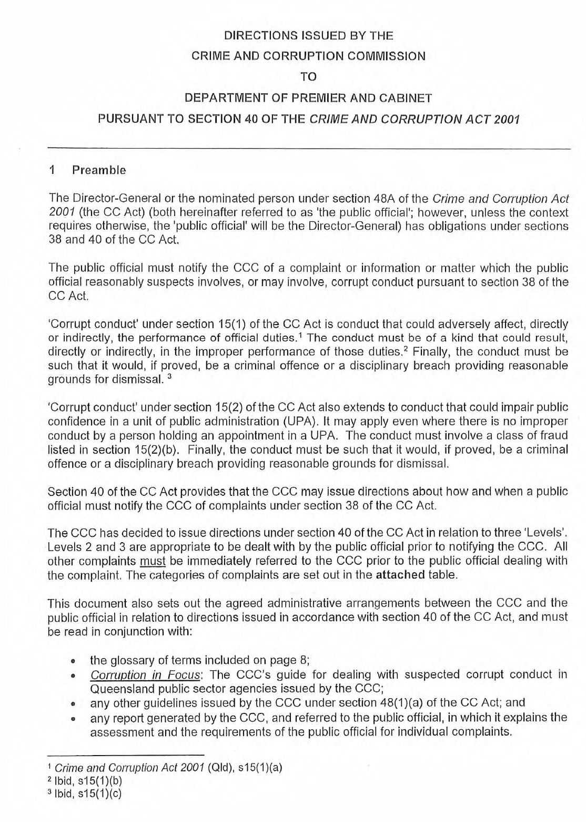

1. see also ss 14, 16, 17 and 18.
2. Section 20 of the CC Act. DPC is a UPA.
3. Section 14 of the CC Act.
4. Section 48(4) of the CC Act.
5. **Persons** means departmental officers whether permanent, temporary, full-time, part-time or casual and any contractor, consultant, volunteer or anyone else who works in any other capacity for the department.
6. Sections 38 and 40 of the CC Act.
7. Sections 40, 43, 44, 46(2) (b) and (f) and 48(1) (c) (ii) of the CC Act.
8. Schedule 2 of the CC Act.
9. Sections 40 and 48(1) (c) of the CC Act.
10. See [www.ccc.qld.gov.au/corruption/information-for-the-public-sector/corruption-in-focus](http://www.ccc.qld.gov.au/corruption/information-for-the-public-sector/corruption-in-focus)
11. See s. 48A of the CC Act and the definitions in section 2 of this policy
12. Section 48A of the CC Act and <insert DPC section 48A policy>
13. Section 13(1) of the *Public Interest Disclosure Act 2010.*  See section 7 of the *Public Interest Disclosure Act 2010* for the meaning of public officer which include an employee, member or officer of the entity.